**LAB # 02**



**Spring 2023**

Submitted by: **Naveed Ahmad**

Registration No: **22pwsce2165**

Class Section: **B**

“On my honor, as student of University of Engineering and Technology, I have neither given nor received unauthorized assistance on this academic work.”

Student Signature: ______________

Submitted to:

**Engineer. Abdullah Hamid**

July 4 2023

Department of Computer Systems Engineering

University of Engineering and Technology, Peshawar

**Lab 02**

**Task 1:**

Write a program that takes the temperature in Fahrenheit from the user and convert it to Celsius And Kelvin.

K= C + 273

C = (F – 32) / 1.8

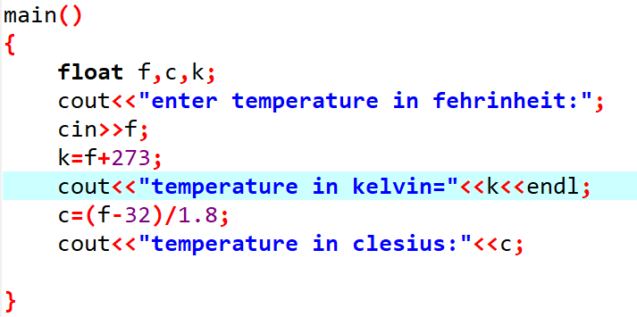

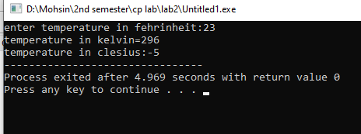

**Output**

**Task 2:**

Write the C++ code that takes 5 numbers (a, b, c, d and e) from the user and display the output according to the following equation.

a3 + b – d / b a (b + c (e + a) / b) - 5

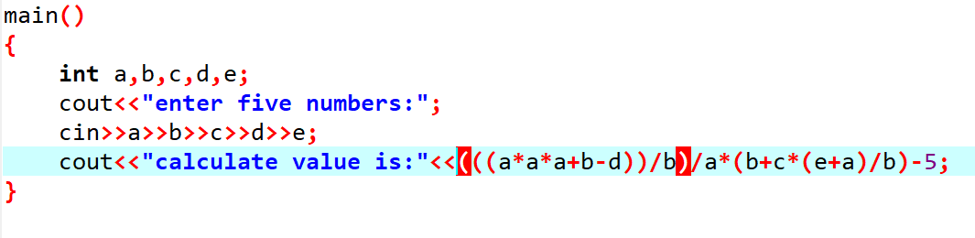

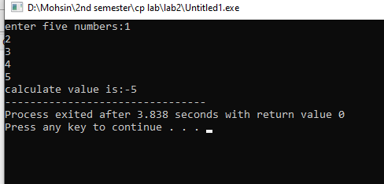

**Output**

**Task 3:**

Write a program to declare two integer and one float variables then initialize them to 10, 11, and 12.6. Also print the variable values on the screen.

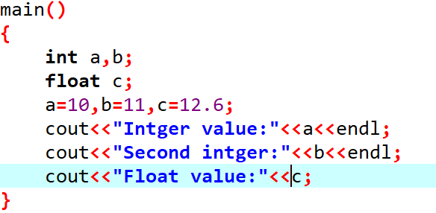

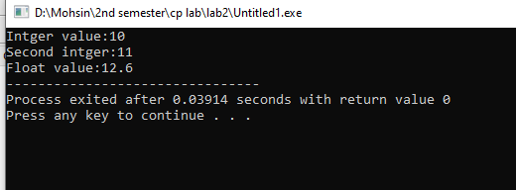

**Output**

**Task 4:**

Write a C++ program to prompt the user to input 3 integer values and print these values in forward and reversed order.

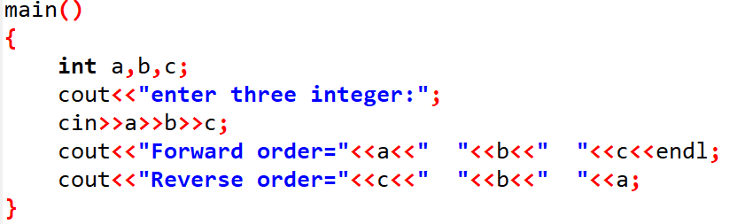

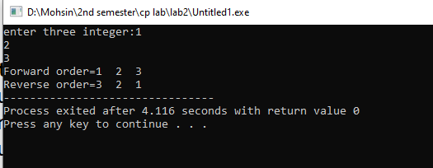

**Output:**

**Task 5:**

Write a program to swap two variables values with and without using third variables.

**Swapping using third variable:**

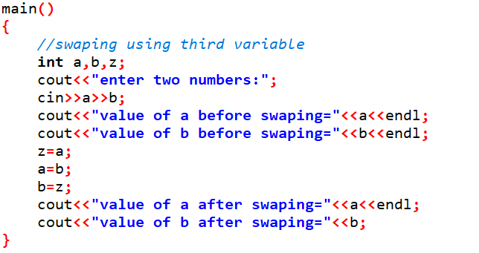

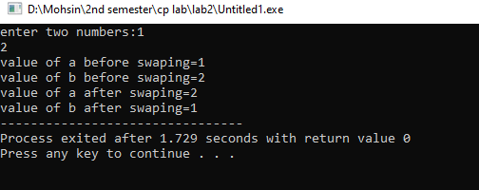

**Output**

***Swapping without using third variable:***

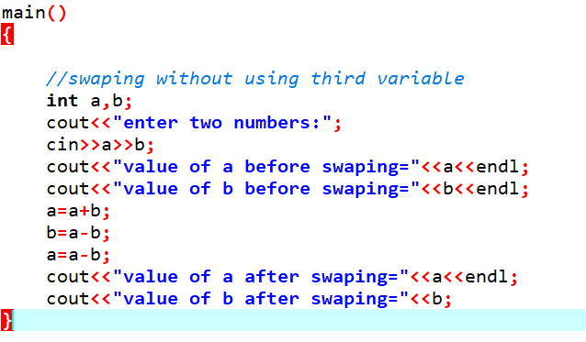

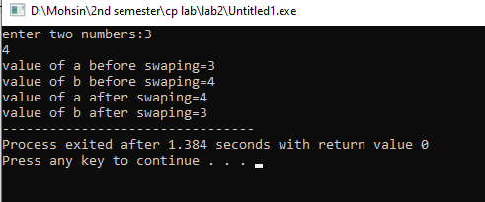

**Output**

**Task 6:**

Write a program to calculate area of a circle having its radius (ask user to input radius).

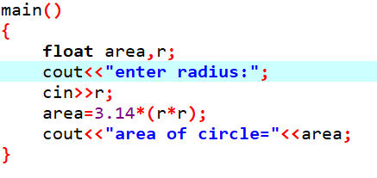

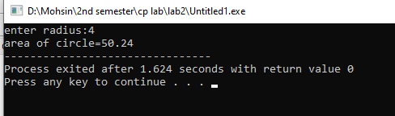

**Output**



**LAB # 03**



**Spring 2023**

Submitted by: **Naveed Ahmad**

Registration No: **22pwsce2165**

Class Section: **B**

“On my honor, as student of University of Engineering and Technology, I have neither given nor received unauthorized assistance on this academic work.”

Student Signature: ______________

Submitted to:

**Engineer. Abdullah Hamid**

July 4 2023

Department of Computer Systems Engineering

University of Engineering and Technology, Peshawar

**Lab 03**

**Task 1:**

Display the largest among three numbers using if else statement?

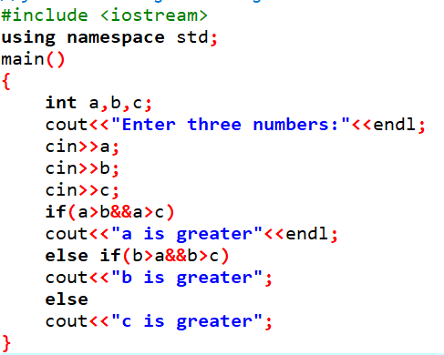

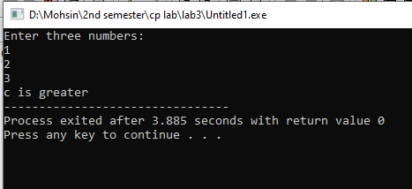

**Output**

**Task 2:**

Check whether a number is even or odd?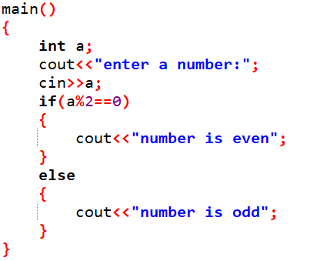

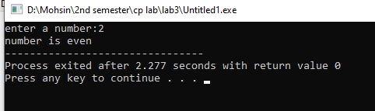

**Output**

**Task 3:**

Check the greater of two numbers using ternary operator?

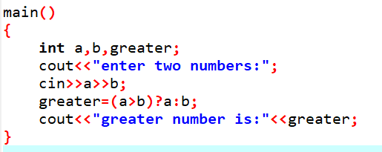

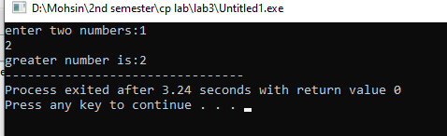

**Output**

**Task 4:**

Write a program where you print you take a number from the user if the number is greater than 2 and then print your name and registration number 2 times or else print only 1 time.

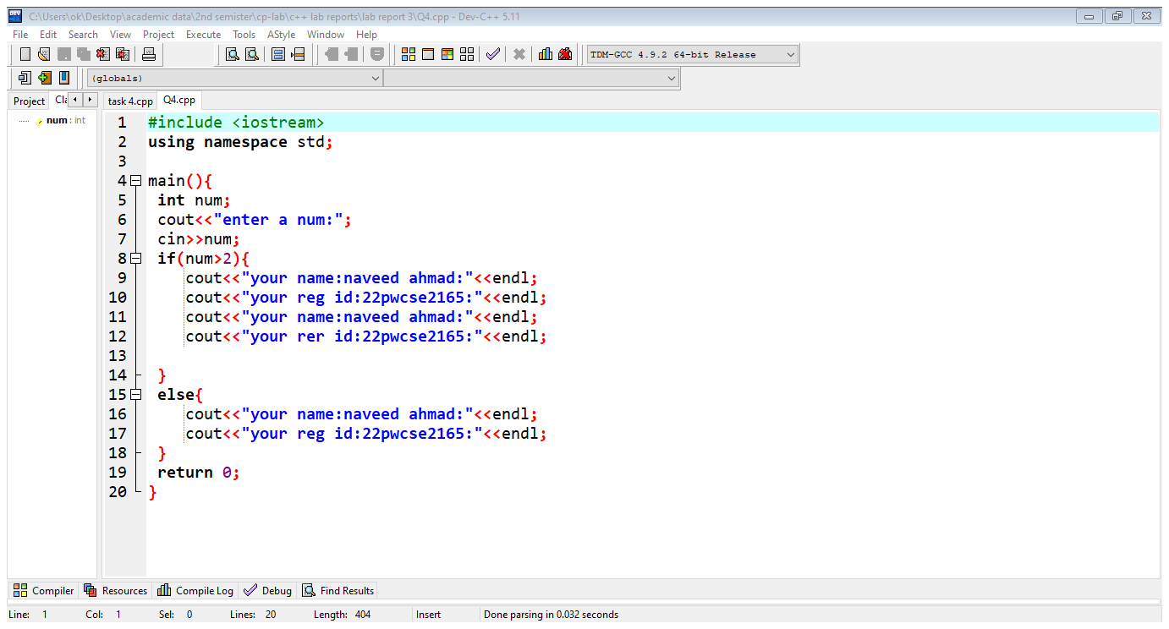

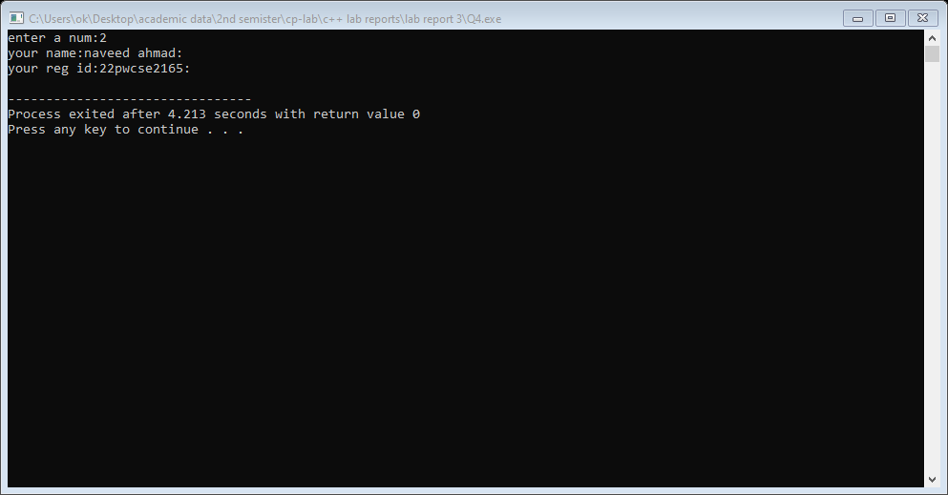

**Output**

**Task 5:**

Write a program that asks a number and test the number whether it is multiple of 5 or not, divisible by 7 but not by eleven. (All three conditions should match).

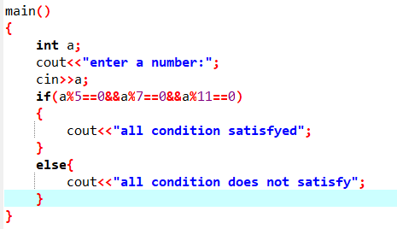

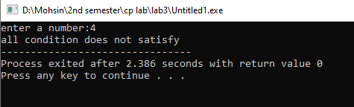

**Output**

**Task 6:**

Check whether the entered character is vowel or consonant?

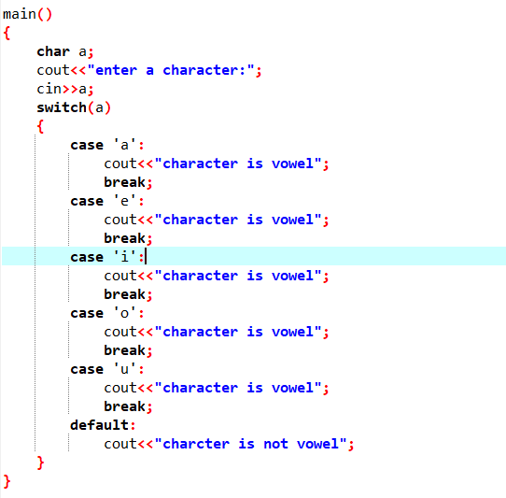

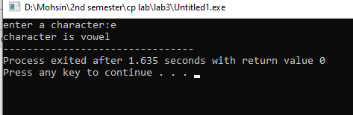

**Output:**

**Task 7:**

Write a program that takes the weekday number as input from user and print the day name of week E.g., Print Monday if weekday number is equal to 1. Similarly, check condition for all 7 days and print the corresponding day name. Print an error message if an invalid number is entered.

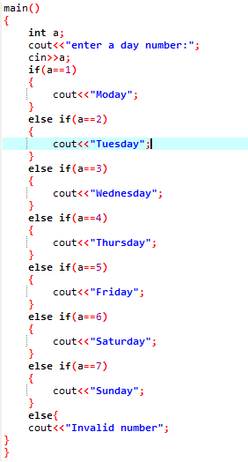

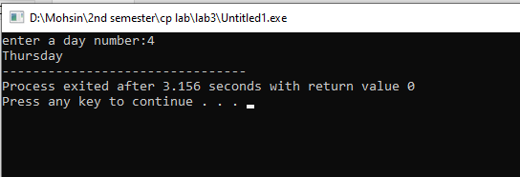**8:**

**Output**

**Task 8:**

Write a C++ program to enter month number between (1-12) and print number of days in month.

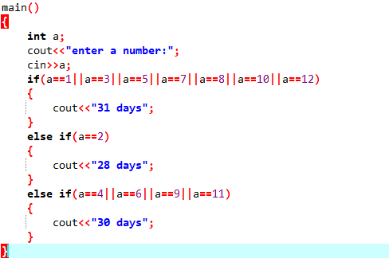

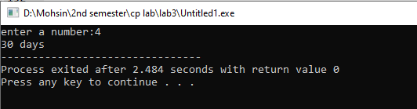

**Task 9:**

Write a program to calculate and print the Electricity bill of a given customer. The customer id and unit consumed by the user should be taken from the keyboard and display the total amount to pay to the customer.

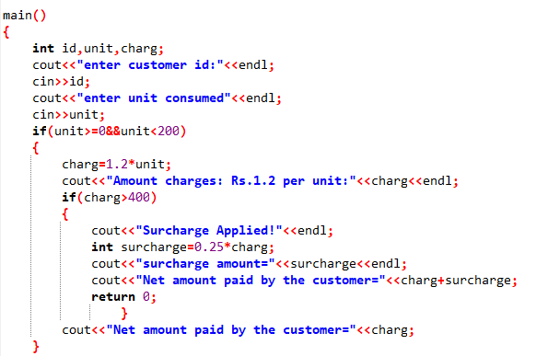

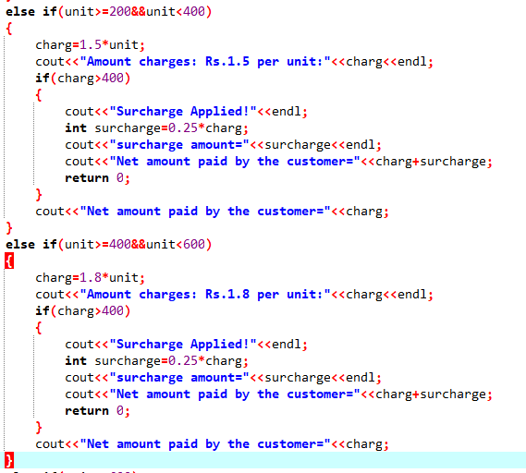

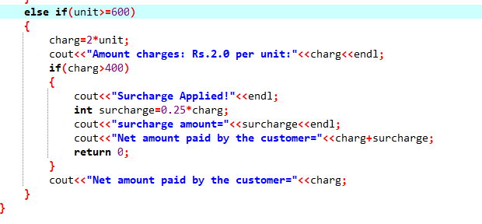

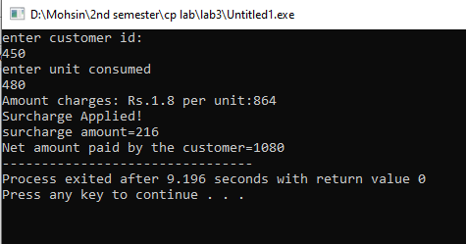

**Output**



**LAB # 04**



**Spring 2023**

Submitted by: **Naveed Ahmad**

Registration No: **22pwsce2165**

Class Section: **B**

“On my honor, as student of University of Engineering and Technology, I have neither given nor received unauthorized assistance on this academic work.”

Student Signature: ______________

Submitted to:

**Engineer. Abdullah Hamid**

July 4 2023

Department of Computer Systems Engineering

University of Engineering and Technology, Peshawar

**Task 1:**

Write a program to create Simple Calculator using switch case (the calculator must have a loop that it could keep on running and ask the user again for input after showing output from the previous inputs).

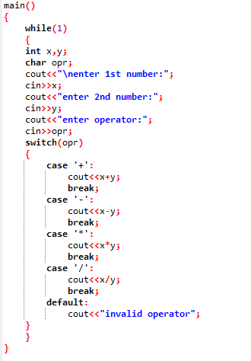

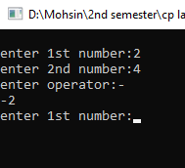

**Output**

**Task 2:**

Write a program that takes a number as input, checks it if it is between 1 and 10 and if it is in valid range your program should output a line containing that number of adjacent asterisks. On invalid input number, the program should end. For example, if your program input is 7, it should print *******.

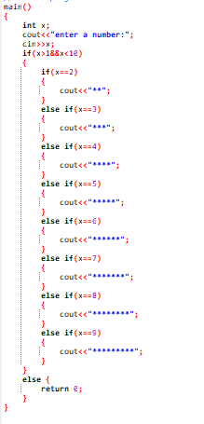

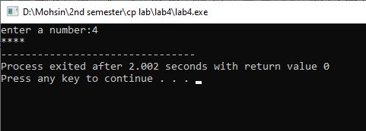

**Output**

**Task 3:**

Write a program to find Factorial of a number.

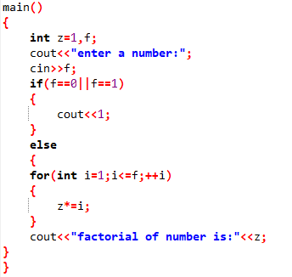

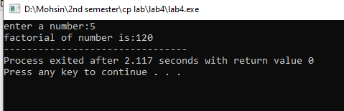

**Output**

**Task 4:**

Write a program to print multiplication table of any number.

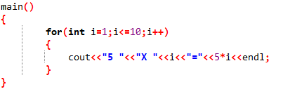

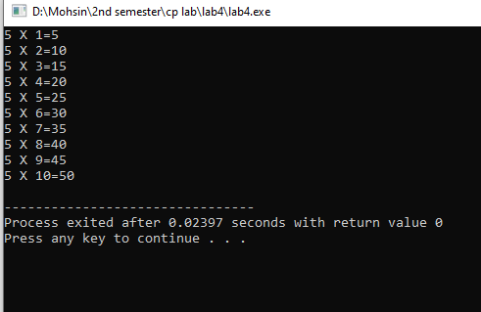

**Output**

**Task 5:**

Write a program to input two integer numbers and display the sum of even numbers between these two input numbers.

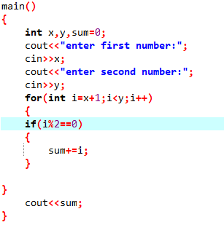

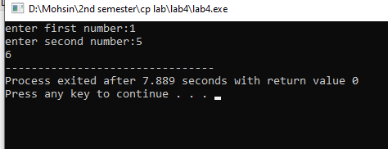

**Output**

**Task 6:**

Write a program that takes the base and exponent as input and display the result of power.

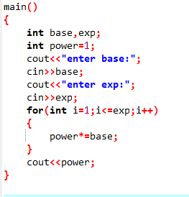

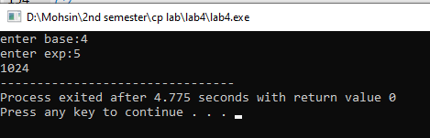

**Output**

**Task 7:**

Write a program that prints your name and registration number 10 times using loop and on the 5th iteration (run) of your loop it should skip and display this “Mid of loop” and then continue displaying your name and registration number.

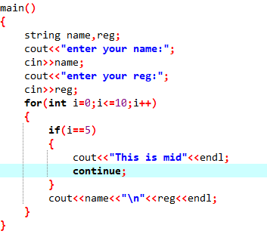

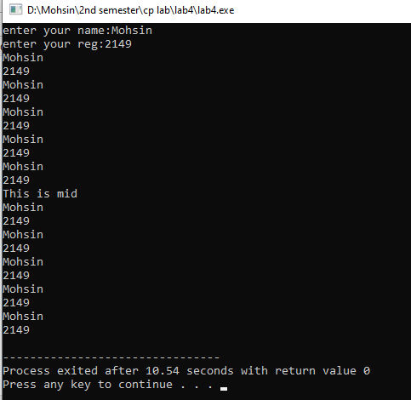

**Task 8:**

Write a program that performs a survey tally on beverages. The program should prompt for the next person until a sentinel value of –1 is entered to terminate the program. Each person participating in the survey should choose their favorite beverage from the following list:

1. Coffee 2. Tea 3. Coke 4. Orange Juice.

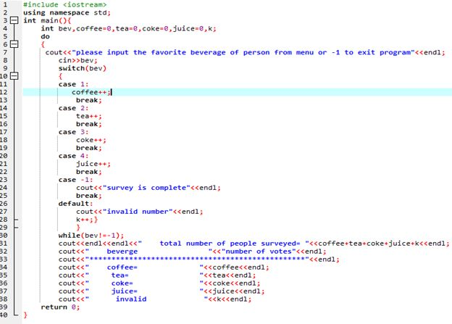

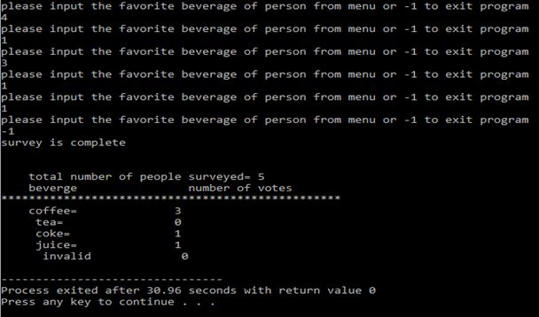



**LAB # 05**



**Spring 2023**

Submitted by: **Naveed Ahmad**

Registration No: **22pwsce2165**

Class Section: **B**

“On my honor, as student of University of Engineering and Technology, I have neither given nor received unauthorized assistance on this academic work.”

Student Signature: ______________

Submitted to:

**Engineer. Abdullah Hamid**

July 4 2023

Department of Computer Systems Engineering

University of Engineering and Technology, Peshawar

**Task 1:**

Write a program to input twelve numbers from user using array and display all values on console (3 values in a row) (use separate loops for input and output operation).

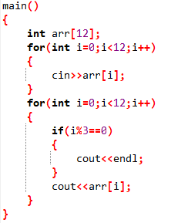

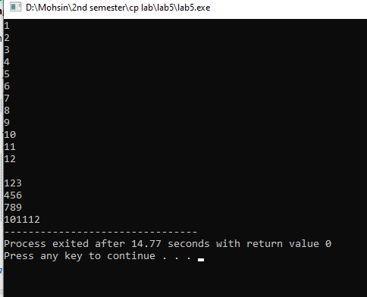

**Task 2:**

Write a program to input two arrays from user and find the sum of arrays (element by element).

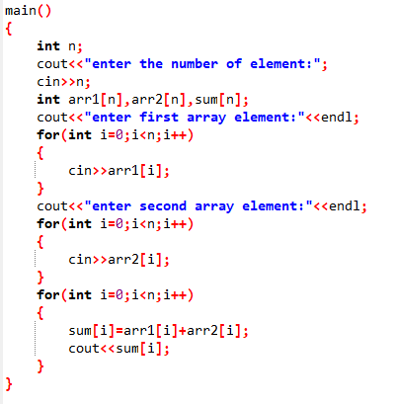

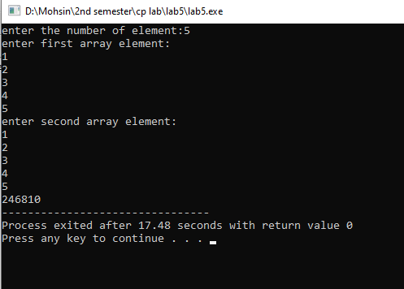

**Output**

**Task 3:**

Write a program to input array from user and display the elements of array in reverse order (use separate loops for input and output operation).

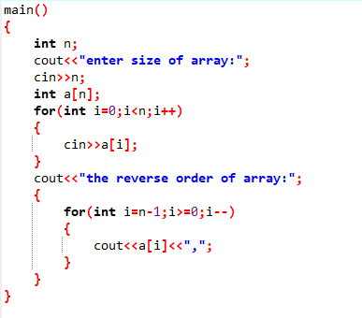

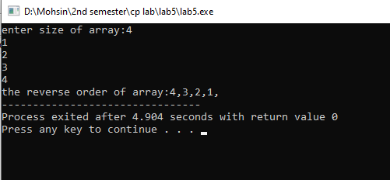

**Task 4:**

Write a program that creates a dynamic array (ask user for its size and its values) and ask user to input a key number, compare it with values entered by the user (in array), if the key gets matched to any of the values in array, display the index number of array where values matches also output “value matched”, if not matched with any of the values simply output “value not matched” (use separate iteration statements for input operation and calculation).

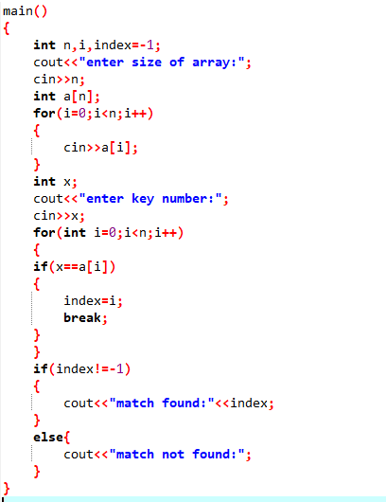

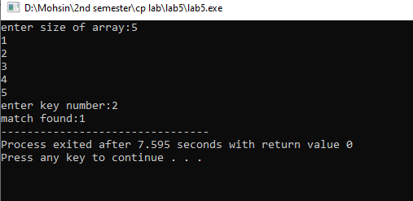

**Task 5:**

Write a program in which you ask the user for the size of array and values for the array (dynamic array, pointer method), find min, max and average of all the values entered by the user in the array (use separate iteration statements for input operations and calculation).

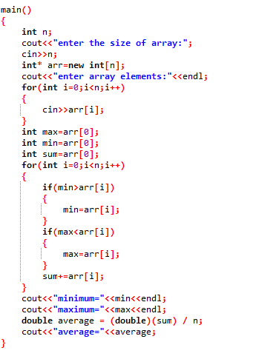

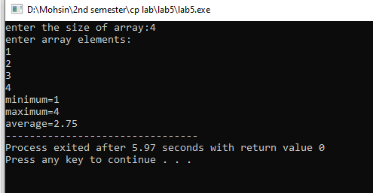

**Output**



**LAB # 06**



**Spring 2023**

Submitted by: **Naveed Ahmad**

Registration No: **22pwsce2165**

Class Section: **B**

“On my honor, as student of University of Engineering and Technology, I have neither given nor received unauthorized assistance on this academic work.”

Student Signature: ______________

Submitted to:

**Engineer. Abdullah Hamid**

July 4 2023

Department of Computer Systems Engineering

University of Engineering and Technology, Peshawar

**Lab 06**

**Task 1:**

Write a program that takes marks and your name as input and then displays your grade using a function that calculates your grade based on your entered marks.

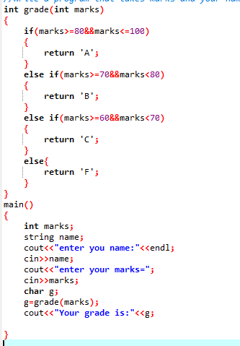

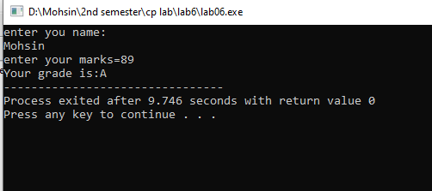

**Task 2:**

Write a function minmax () that takes four integers as input and display the minimum and maximum number

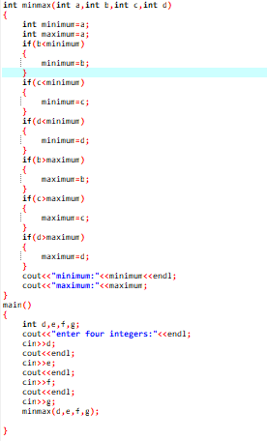

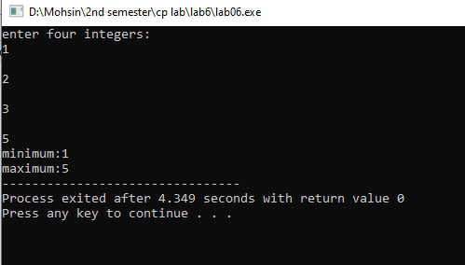

**Output**

**Task 3:**

Create a function named ‘prime’ which accepts an integer and return a Boolean (a true if the number is prime and false otherwise).

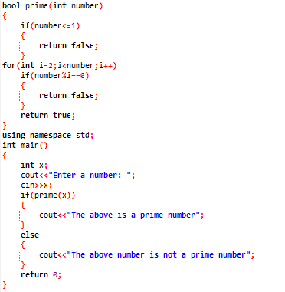

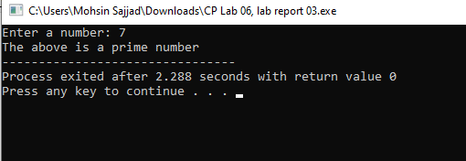

**Output**

**Task 4:**

Write a program to find a factorial of number entered by the user. Use function to find factorial.

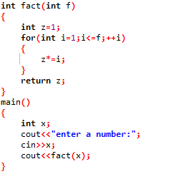

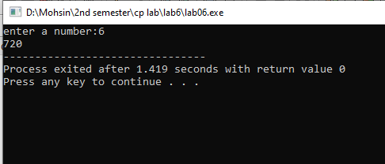

**Output**

**Task 5:**

Write a program to find the roots of a quadratic equation of type a.x2 +b.x+c where the value of a, b, c is to be entered by the user inside main(). Make sure value of a must be non-zero, if it is complete the program. There must be two function one called roots() (non-return type) the other called deter() (return type).

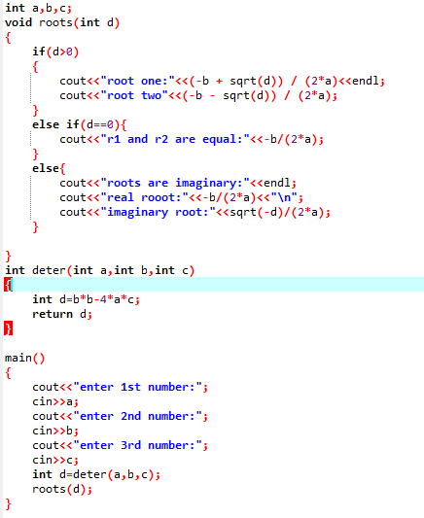

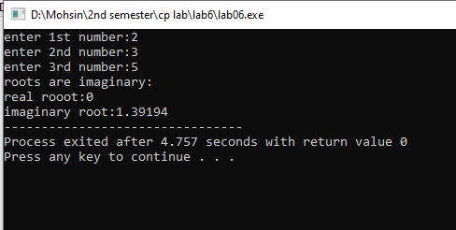

**Output**



**LAB # 07**



**Spring 2023**

Submitted by: **Naveed Ahmad**

Registration No: **22pwsce2165**

Class Section: **B**

“On my honor, as student of University of Engineering and Technology, I have neither given nor received unauthorized assistance on this academic work.”

Student Signature: ______________

Submitted to:

**Engineer. Abdullah Hamid**

July 4 2023

Department of Computer Systems Engineering

University of Engineering and Technology, Peshawar

**Task 1:**

Write a C++ program where you take two values from user if the user enters one or two of the values zero instead of passing the zero values to the function let the function calculate default values if user enters values other than zero pass them to function and calculate their sum.

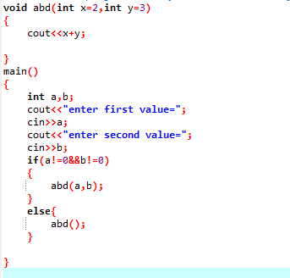

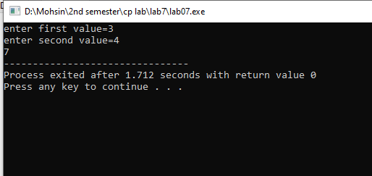

**Output**

**Task 2:**

Create a function template that can change its return type and parameters type according to the data entered by the user (first ask the user for the type of data that will be entered float, int or double then ask for two numbers, using the type information call the function template).

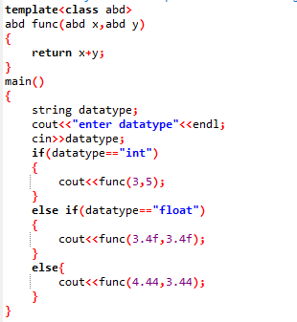

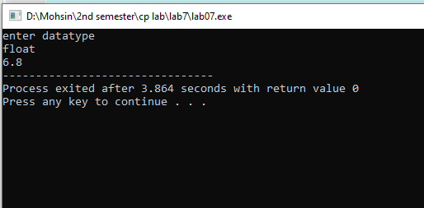

**Task 3:**

Calculate the sum of odd natural numbers 1+3+5+7+……………. + n using Recursion. Take n as input from user.

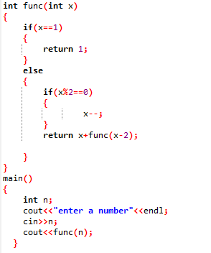

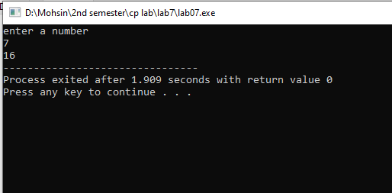

**Ptask 4:**

Overload three functions with name “grade”, the first grade function should be nonreturning void type with no parameter, void grade(), the second should have integer parameter and return type float, float grade(int marks) the third function should have float parameter and its return type should be char, char grade(float percentage). Your main() should only call the first function, the first function will prompt the user to enter marks then it will pass the marks to the second function where it will calculate the percentage and return the percentage to the first function, then the first function will send the percentage to the third function where it will calculate the grade based on the percentage will return the grade to first function in the form of char. Finally, the first function will display the grade as well as the marks and the percentage. Consider total marks = 150.

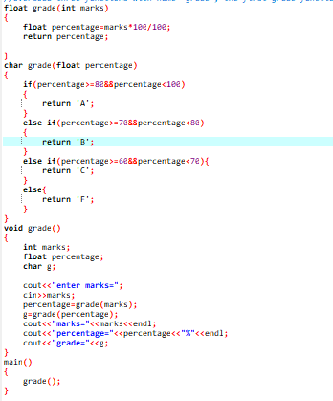

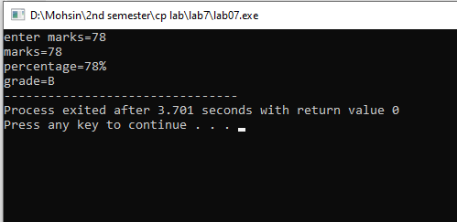

**Output**

**Task 6:**

Write a C++ Program to Find Factorial of a Number Using Recursion.

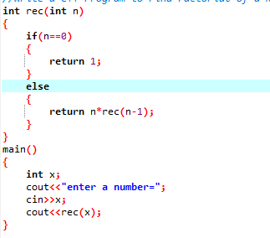

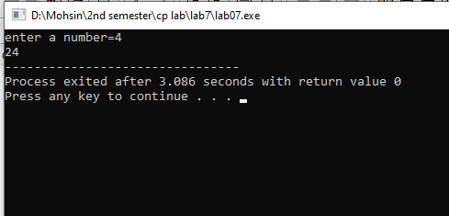

**Output**

**Task 7:**

C++ program to calculate power of a number using recursion.

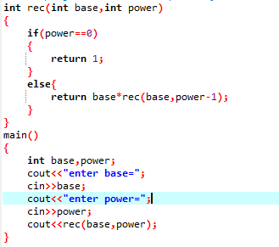

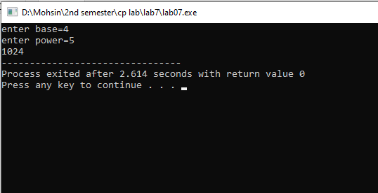

********

**Lab 8&9**

**Program 1:**

Write a C++ program where you take two values in two variables from user, add the values of the two variables and put it into a third variable using a pointer. you must you only one pointer.

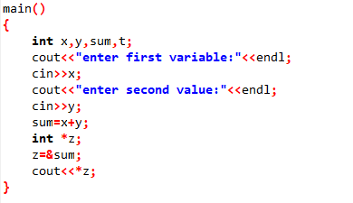

**Output:**

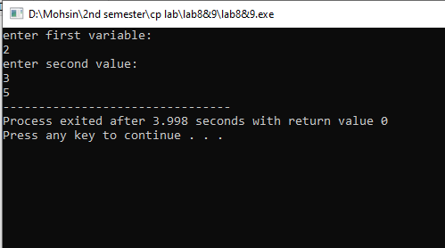

**Program 2:**

Create a string array of size 2, in the first element enter your name and in the second element enter your registration number, using a pointer, now pass the array address to function called display(), which has a string pointer as a parameter, the function will display both elements of the array.

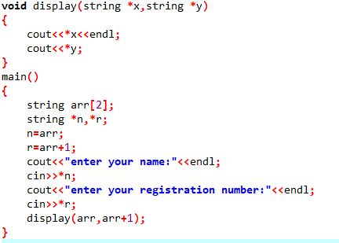

**Output:**

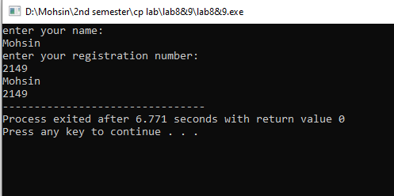

**Program 3:**

Write a program which calculates the average of an array of 5 elements (initialize the values of the array during declaration) the average should be calculated in a function called average(), this function will have a pointer parameter (array must be passed here) and an integer parameter (which is the size of array) i.e., average(int *arr , int size).

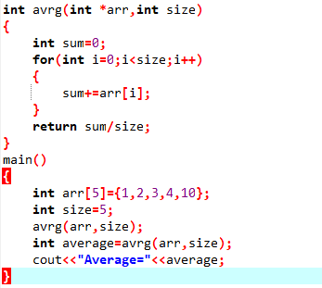

**Output:**

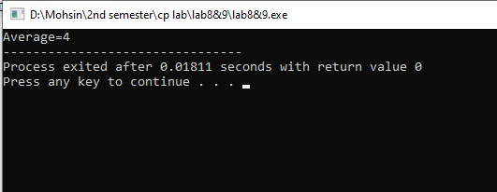

**Program 4:**

Write a C++ program where you create 2 functions (percentage, GPA) and a 3rd function called caller, the caller will have one integer and a pointer to function as parameters. In the main function you must prompt the user to enter marks, then prompt him again to ask what he wants to find out, GPA (assume 90-100 marks = A = 4.0 GPA and so on) based on marks or percentage based on marks. Then call the caller function accordingly.

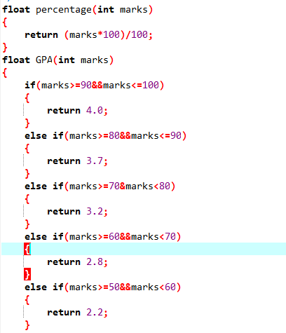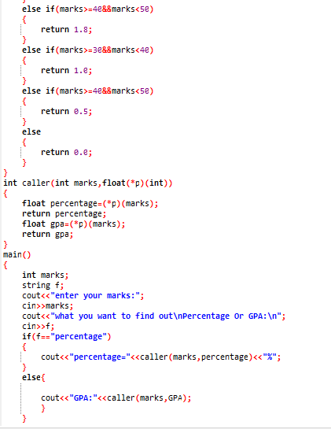

**Output:**

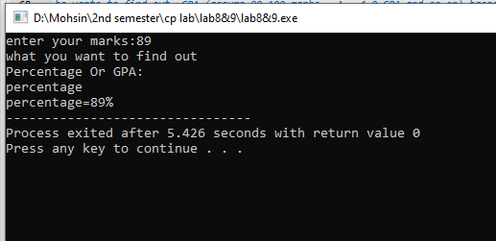

**Program 5:**

Write a C++ program where you declare an array of 5 elements, create a pointer that points to the array, then ask the user to input 4 values in the array using pointer (keep the last index value 0), now to declare two separate integers that will act as the indexes of the array, ask the user to input values in them (if the user enters 3,2 so arr+2, arr+1). Now finally send the two array indexes values to a function, the function must have two pointers as parameters. The function will add the two values on index locations and put them back in the fifth index/element of the array replacing the 0. Display the updated fifth index of array in main().

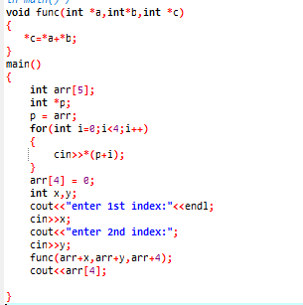

**Output:**

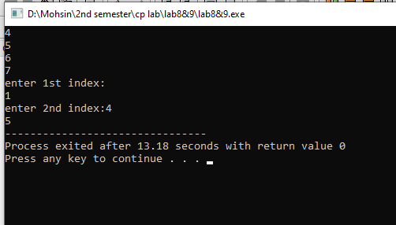

********

**Lab 10 & 11**

**Program 1:**

A phone number such is (091) 767-8900 can be thought of as having three parts: the area code (091), exchange (767) and number 8900. Write a program that uses structure to store these 3 parts of a phone number separately. Assume name of the structure is ‘phone’. Create two objects of type ‘phone’, initialize one object and take the other one from the user. Display both numbers. Sample Run:

Enter you Area code, exchange, and number: 091 767 8900

My number is (042) 867-4982

Your number is (091) 767-890

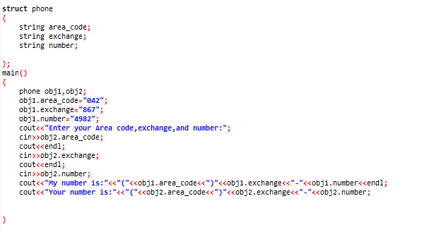

**Output:**

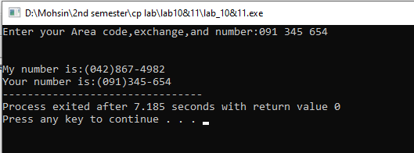

**Program 2:**

A point on a two-dimensional space has two numbers: an ‘X’ coordinate and a ‘Y’ coordinate such as (4, 5). Write a program that uses a structure called ‘point’ to model a point and draw a rectangle of ‘*’ based on the entered height and width of the rectangle. Sample Run:

Enter the point coordinates: (x, y) 3 2

Enter width of the rectangle: 3

Enter Height of the rectangle: 2

* * *

* * *

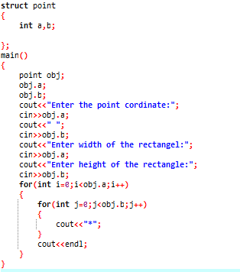

**Output:**

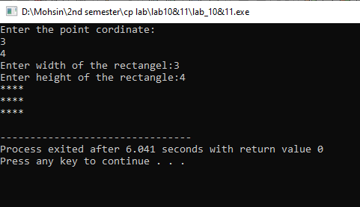

**Program 3:**

Write a program to develop student information system. This system should be able to take the student’s credentials, like name, reg no and semester no, as input and store them in a structure object Student_t. The system should be capable of storing the information of multiple students. And it should be capable of displaying the student’s information, when asked to do so, via reg no.

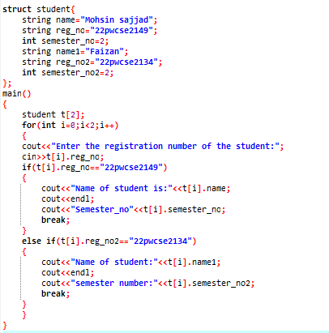

**Output:**

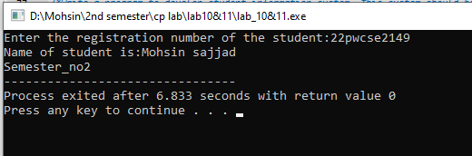

**Program 4:**

Make a C++ Program that will have base class called input, the input class should have 3 data members name (string), reg no (string), semesterNo (int) and 2 special member functions, constructor, and destructor. The constructor must prompt the user to enter data into the three data members and the destructor should only output a simple phrase like “end of program”. Now make a second inherited class called output which will only have 1 member function called display(), this function will display the values of the data members of the input class.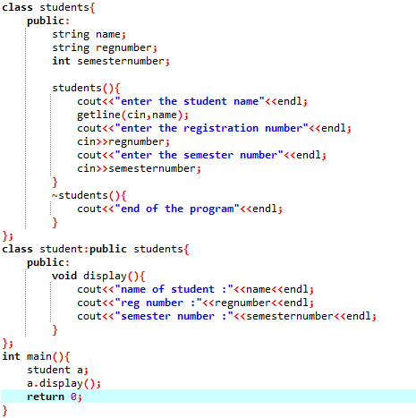

**Output:**



